University of Warsaw
Faculty of Economic Sciences

Filip Szymański, Aleksander Wieliński
Album N°: 427618, 420272

Title

Master thesis degree
Field of study: Data Science and Business Analytics

Thesis written under the supervision of
dr hab. Katarzyna Kopczewska, prof.ucz.
from Chair of Statistics and Econometrics
WNE UW

Warsaw,

Declaration of the supervisor
I declare that the following thesis was written under my supervision and I state that it meets all
criterias to be submitted for the procedure of academic degree award.

Date Signature of the Supervisor

Declaration of the author of the thesis
Aware of the legal responsibility, I declare that I am the sole author of the following thesis and that the thesis is free from any content that constitutes copyright infringement or has been acquired contrary to applicable laws and regulations.

I also declare that the thesis has never been a subject of degree-awarding procedures in any higher education institution.

Moreover, I declare that the attached version of the thesis is identical with the enclosed electronic version.

Date Signature of the Author

Summary

Key words

Field of the thesis (codes according to the Erasmus program)

Thematic classification

The title of the thesis in Polish

Data

Exploratory Spatial Data Analysis
The subsequent analysis begins by examining what percentage of mid/high-tech companies belong to each area defined as dist_(core, midsize, regional, localbig, localsmall)_(10, 25, 50), and to the COREfirms, COREpopul clusters. We created a crosstab which counted the number of mid/high-tech companies that matched the results of the selected variables, and divided it by the total number of mid/high-tech companies (see Table 1).
Table 1. Crosstab results
Variable | Percentage  matching  (high-tech) | Percentage  matching  (non-high-tech) | High-tech  (0) | High-tech  (1) | Non-high-tech (0) | Non-high-tech (1)
COREfirms | 94.38% | 68,08% | 2379 | 39962 | 300455 | 640923
COREpopul | 96.85% | 74,20% | 1333 | 41008 | 242915 | 698463
dist_core_10 | 56.54% | 32,36% | 18402 | 23939 | 636719 | 304659
dist_core_25 | 84.41% | 51,42% | 6601 | 35740 | 457343 | 484035
dist_core_50 | 90.43% | 63,25% | 4050 | 38291 | 345968 | 595410
dist_midsize_10 | 1.72% | 3,18% | 41611 | 730 | 911483 | 29895
dist_midsize_25 | 3.60% | 8,72% | 40816 | 1525 | 859260 | 82118
dist_midsize_50 | 5.04% | 16,37% | 40205 | 2136 | 787247 | 154131
dist_regional_10 | 7.88% | 7,85% | 39005 | 3336 | 867489 | 73889
dist_regional_25 | 72.07% | 52,06% | 11824 | 30517 | 451294 | 490084
dist_regional_50 | 94.11% | 79,01% | 2494 | 39847 | 197607 | 743771
dist_localbig_10 | 45.17% | 33,20% | 23216 | 19125 | 628852 | 312526
dist_localbig_25 | 90.83% | 65,21% | 3884 | 38457 | 327510 | 613868
dist_localbig_50 | 94.97% | 80,99% | 2128 | 40213 | 178933 | 762445
dist_localsmall_10 | 77.72% | 53,33% | 9434 | 32907 | 439298 | 502080
dist_localsmall_25 | 95.88% | 83,37% | 1746 | 40595 | 156567 | 784811
dist_localsmall_50 | 99.90% | 98,88% | 42 | 42299 | 10550 | 930828

To begin with, the dissimilarity between the results for high-tech and non-high-tech companies for the variables COREfirms and COREpopul. A relative comparison of the results indicates a much higher concentration of high-tech companies around densely populated areas and areas with a large number of firms. Results close to 95% for both variables for high-tech companies clearly indicate that the location of these companies is not random, and it is necessary to focus on a deeper analysis of this phenomenon and take this fact into account when formulating the research hypothesis.
A comparison of the results for the dist_core and dist_midsize variables also shows a certain regional dependence. Assuming that the variable dist_core_10 corresponds to areas roughly the size of Warsaw's city center, and the variable dist_core_25 also covers its suburbs, the results of 56.64% and 85.41%, respectively, indicate a very high concentration of high-tech companies just in the Warsaw region. In comparison, non-high-tech companies falling into the dist_core_25 area account for only half of all non-high-tech companies in the Mazovian region. Moreover, for the variables dist_midsize_(10,25,50), which corresponds to the location around Radom and Plock, (also dist_regional, which corresponds to cities with a population of 50k+) the results are very low. This indicates the overwhelming dominance of large cities in terms of locating high-tech companies.
Figure 1. Spatial distribution of mid/high-tech firms
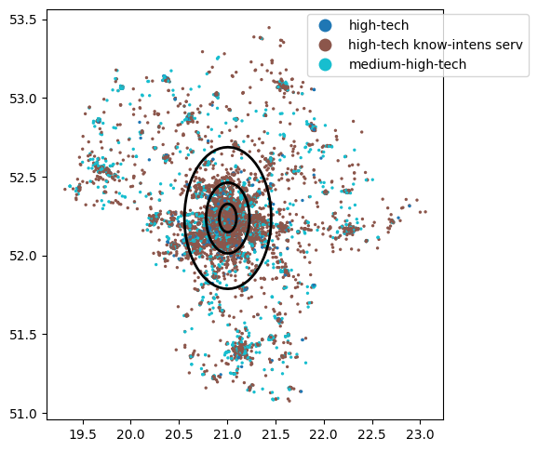
The insights from the above analysis can be visualized in the graph (see Figure 1). The chart shows the point distribution of high-tech companies in the Mazovian Voivodeship. It clearly shows the concentration of companies around larger agglomerations characterized by higher population density, as well as the huge density in the very center of Warsaw and its suburbs. The chart has been plotted with 3 circles corresponding to areas with a radius of 10, 25 and 50 kilometers from the center of Warsaw. Based on the results from the crosstab analysis, 56.54%, 84.41% and 90.43% of all high-tech companies are located in these areas, respectively.
The next step from the preliminary analysis was to visualize and plot three variables: locPdens - the number of residents in the direct neighbourhood of 500m from a given company, locAggTotal - the number of companies in the direct neighbourhood of 500m from a given company, and locBIG - the number of companies classified as large in the direct neighbourhood of 500m from a given company (see Figure 2). Cross-referencing the graph of the locPdens variable with the graph for high-tech companies, one can clearly see clusters forming around larger urban areas, where population density is higher. This coincides with the conclusions of the crosstab analysis, and also, such phenomenon can be found in the literature (Kopczewska et al. 2023). The same is true for the variable locAggTotal, where we also see a tendency for high-tech companies to locate in areas with more companies. However, the trend is not as clear-cut as in the case of population. The chart shows that the areas to the east and northeast of Warsaw do not overlap in all places when compared with the density of mid/high-tech companies. Nevertheless, looking at the graph for the locBIG variable at the same time, we can see that there are relatively more companies classified as large in these areas, which may influence the lack of bright shades shown in the graph for the locAggTotal variable.
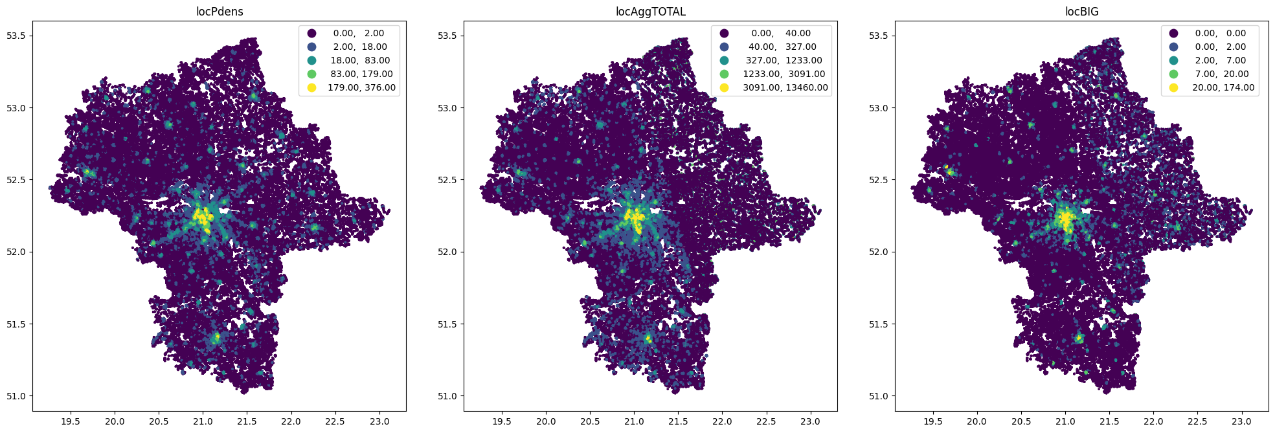
Figure 2. Spatial distribution of variables locPdens, locAggTotal and locBIG

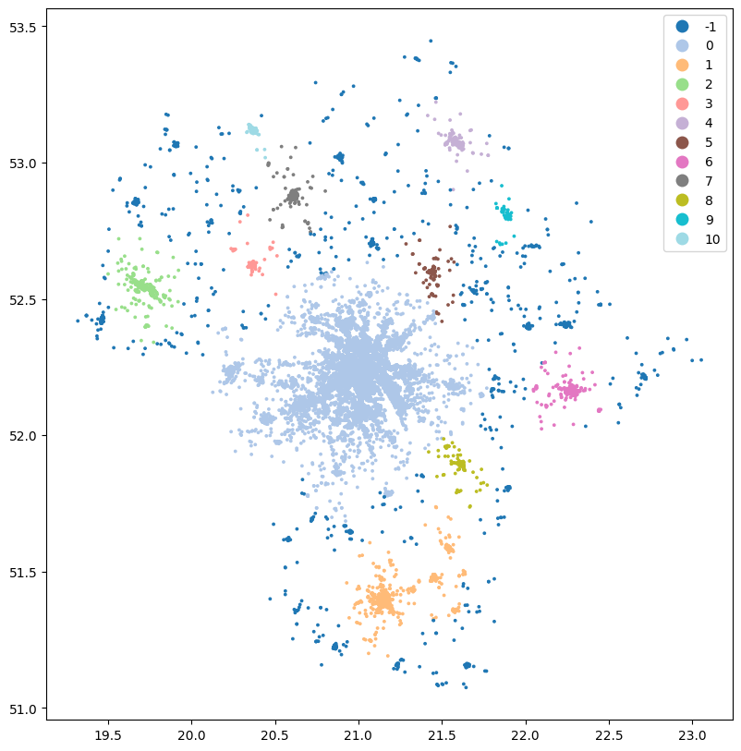

Literature Review
While studying spatial data, one of the fundamental steps is to examine the spatial distribution of our variables. Geo-located points, irrespective of assigned features, are distinguished by their longitude and latitude (x, y) coordinates on a projection. Using this data, it is possible to gather observations into spatial clusters that exhibit spatial continuity, encompassing all points under analysis (Kopczewska, 2021). There are many unsupervised machine learning techniques for clustering, which are differentiated primarily by measuring distance, e.g. Euclidean, Manhattan, Minkowski etc., how the assignment to a given cluster is decided, and how the center point in a given cluster is formed. K-means is one of the most popular and simplest unsupervised learning techniques for clustering data. It divides a set of n observations into k clusters, assigning each observation to the cluster with the closest mean. The primary goal of this algorithm is to minimize a specific objective function, which in this context is a squared error function. (Ansari, 2021). For relatively modest sample sizes (n), the k-means algorithm can be effectively applied, however, its suitability diminishes as n grows due to the need for calculating a resource-intensive n × n mutual distance matrix (Kopczewska, 2021). As Ansari (2021) states, in the case of B2B market segmentation analysis, the k-mean algorithm could not find any useful clusters out of the data set. Instead, the unsupervised Self-Organizing Map (SOM) has demonstrated its proficiency in identifying both geographically uniform and geographically diverse areas across the United States.
There are two main problems with the K-means algorithm. One is that the user has to determine the number of clusters a priori, either based on intuition or simply by guess. The second is that the algorithm does not detect noise observations, creating clusters using all the data provided, also taking into account observations that do not contribute to the formation of clusters. Recognising these challenges, another approach known as the DBSCAN (Density-Based Spatial Clustering of Applications with Noise) algorithm was developed to address some of the limitations of the K-means method. Unlike K-means, DBSCAN doesn't require you to preset the number of clusters. It works by identifying clusters based on the density of points within a specified radius, rather than relying on a predetermined number. Central to the DBSCAN algorithm are the concepts of "core points," "border points," and "noise." Core points require a certain number of neighbouring points within a defined distance, border points exist near core points but lack the required density, and noise points are too distant from core points to be grouped into clusters.

Useful articles with short descriptions
- Benbrahim Ansari O. Geo-Marketing Segmentation with Deep Learning. Businesses. 2021; 1(1):51-71. https://doi.org/10.3390/businesses1010005
The research deals with the capability of unsupervised deep learning to perform geospatial clustering in the B2B marketing context in Germany. The author uses algorithms such as K-means and Self-Organizing Map (SOM).
- Kinne, Jan and Resch, Bernd, Analysing and Predicting Micro-Location Patterns of Software Firms (2017). ZEW - Centre for European Economic Research Discussion Paper No. 17-063 http://dx.doi.org/10.2139/ssrn.3082822
The study involves analyzing and predicting micro-location patterns of software firms in Germany. It consists of Exploratory Spatial Data Analysis and two regressions of Poisson and Negative Binomial. The authors strongly criticize the use of aggregated data when analyzing at the micro-geographic level. They used a comprehensive dataset of three million street-level geocoded firm observations from OpenStreetMap (OSM).
- Sang-Hyun Chi, Diana S. Grigsby-Toussaint, Natalie Bradford, Jinmu Choi, Can Geographically Weighted Regression improve our contextual understanding of obesity in the US? Findings from the USDA Food Atlas, Applied Geography, Volume 44, 2013, Pages 134-142, ISSN 0143-6228, https://doi.org/10.1016/j.apgeog.2013.07.017.
The authors examine the interaction between food environment, demographic factors, socioeconomic conditions and obesity occurrence in the United States. The study uses a k-means clustering algorithm as well as Geographically Weighted Regression (GWR), and compares the findings with a simple OLS to reveal how these relationships show spatial disparities across US counties.
- Appelhans, Tim, et al. "Evaluating machine learning approaches for the interpolation of monthly air temperature at Mt. Kilimanjaro, Tanzania." Spatial Statistics 14 (2015): 91-113. https://doi.org/10.1016/j.spasta.2015.05.008
The researchers estimate climate data across a landscape, based on temperature measurements from different spots on Mt. Kilimanjaro. They tried 14 machine learning methods to predict temperatures, comparing them to a common approach called kriging. After testing, they found that some machine learning methods, especially regression trees, worked better than kriging for accuracy. But when looking at the maps, they suggest using a combination of methods for better results.
- Zandiatashbar, Ahoura, and Shima Hamidi. "Transportation amenities and high-tech firm location: An empirical study of high-tech clusters." Transportation Research Record 2675.12 (2021): 820-831. https://doi.org/10.1177/03611981211031219
The study examines how high-tech firms and transportation infrastructures relate to economic development by applying a series of logit models. Authors state that it is believed that tech firms gather in clusters for efficiency, favouring walkable and transit-friendly areas. However, this research finds that not all tech industries follow this pattern; some prefer car-centric locations due to factors like logistics and the rise of the e-economy. By analyzing data from different high-tech sectors across the U.S., the study recommends that policymakers consider sector-specific differences when planning economic growth strategies.
- He, Zekai, and Michael Romanos. "Spatial agglomeration and location determinants: Evidence from the US communications equipment manufacturing industry." Urban Studies 53.10 (2016): 2154-2174. https://doi.org/10.1177/0042098015586698
The study investigates the clustering of communications equipment manufacturing (CEM) in US metropolitan areas. It analyzes how vertical and horizontal industrial connections, along with corporate taxation, influence the choice of CEM establishment locations. The researchers employ discrete count data regression models and panel data regression models for testing. Results show that both types of linkages significantly contribute to CEM spatial agglomeration, confirming that local input-output connections matter.
- López, Fernando A., and Antonio Páez. "Spatial clustering of high‐tech manufacturing and knowledge‐intensive service firms in the Greater Toronto Area." The Canadian Geographer/Le Géographe Canadien 61.2 (2017): 240-252. https://doi.org/10.1111/cag.12326
The study's goal is to explore the clustering of high-tech and knowledge-intensive firms in the Greater Toronto Area, Canada. To achieve this, a spatial scan statistic is utilized. The findings suggest that the presence of transportation infrastructure and skilled labour play a pivotal role in forming industrial clusters.
- Jofre‐Monseny, Jordi, Raquel Marín‐López, and Elisabet Viladecans‐Marsal. "The determinants of localization and urbanization economies: Evidence from the location of new firms in Spain." Journal of Regional Science 54.2 (2014): 313-337. https://doi.org/10.1111/jors.12076
The research analyzes the choices of newly established manufacturing firms in Spain, examining both city-level and industry-specific factors. For this purpose, the authors applied the Negative Binomial and Zero Inflated Poisson Model. The findings indicate that urbanization effects are prominent in knowledge-intensive sectors, suggesting these industries benefit from knowledge exchange in urban centers. Similarly, localization effects are pronounced in industries relying on industry-specific skilled workers, implying they cluster to access a shared pool of specialized labor.
- Wu, Kangmin, et al. "Relationship between the built environment and the location choice of high-tech firms: Evidence from the Pearl River Delta." Sustainability 11.13 (2019): 3689. https://doi.org/10.3390/su11133689
This study uses data from high-tech firms in the Pearl River Delta to develop a framework for the built environment, considering various aspects. They apply spatial regression and geographical detector techniques to reveal the relationship between the built environment and high-tech firm concentration. The findings showcase a concentrated distribution of high-tech firms, with technology support, transport infrastructure, and certain living services positively impacting their clustering. On the other hand, the study points out the negative effect of public service levels.
- Kanevski, M.; Pozdnukhov, A.; and Timonin, V., "Machine Learning Algorithms for GeoSpatial Data. Applications and Software Tools" (2008). International Congress on Environmental Modelling and Software. 53
Machine learning trends in geolocation and environmental sciences include reducing complex data for visualization, analyzing high-dimensional geographic data, quickly modeling physical processes using hybrid approaches, and predicting spatio-temporal patterns for data mining and forecasting. Trends worth noting are: Nonlinear Dimensionality Reduction and Data Visualization, High-Dimensional Geo-Feature Space Analysis, Rapid Hybrid Modeling, Spatio-Temporal Patterns and Predictions
- Camila Balbontin & David A. Hensher: Firm-specific and location specific drivers of business location and relocation decisions, Transport Reviews (2018), DOI: 10.1080/01441647.2018.1559254
This paper discusses the importance of understanding the factors influencing firm location and relocation decisions within the context of integrated transport and land use models. While research on residential location is extensive, less attention has been given to firm location choices. The paper reviews existing literature and suggests gathering data for future empirical studies, including both revealed preference and stated choice data. The challenge lies in determining who to interview and whether to model at a firm level or aggregate level.
- João J. M. Ferreira & Cristina I. Fernandes & Mário L. Raposo, “The Effects of Location on Firm Innovation Capacity”, Springer Science+Business Media New York 2015, https://doi.org/10.1007/s13132-015-0281-4
In this cross-sectional study involving 844 firms, the article explores the impact of location on firms' innovative capacities and financial performance. It contributes to evolving location theories by observing trends towards eclecticism. The study finds that older entrepreneurs establish companies with high innovative capacities and strong financial performance. Location influences innovation capacities, particularly in urban centers like the Lisbon region due to proximity to resources and innovation networks. The Knowledge-Intensive Business Services (KIBS) sector exhibits higher innovation capacities, while process-based innovation is lower in KIBS compared to manufacturing and construction sectors. The study suggests investigating organizational culture's role in this difference. Geographical proximity, specifically in the Lisbon region, positively affects innovation capacity. Companies with higher turnovers generate more innovations, correlating with better financial performance and regional economic development.
- Jae Teuk Chin, “Location Choice of New Business Establishments: Understanding the Local Context and Neighborhood Conditions in the United States”, Department of City and Regional Planning, School of Urban Affairs and Public Policy, University of Memphis 2020
This research investigates factors influencing where new businesses are established in the U.S. It looks at both regional and neighborhood influences, with a focus on small businesses targeting local markets. Neighborhood factors like employment and population density significantly impact new businesses. Vacant housing reduces establishments, revealing economic vulnerability. Industrial dominance can exclude unrelated businesses. Results at the metro level show warmer climates attract more businesses. Urbanization effects are weaker in medium-sized metros. The study acknowledges that new businesses vary and suggests considering industry and firm size in future research. Unobservable factors like founder preferences and local regulations also matter.

Dalsze kroki i metodyka badawcza
- Podzielenie firm na sektory względem kodu PKD7 (tak jak to zostało zrobione w Pani pracy) i próba ich klasteryzacji. Wstępnie zbadaliśmy korelację zmiennych w bazie, jednak nie otrzymaliśmy obiecujących wyników, co z naszych podejrzeń może być związane ze zbyt granulowanym podziałem kodów PKD.
- ESDA dla firm finansowych i produkcyjnych podobna jak dla firm high-tech
- Zastanowienie się nad dodatkowym czynnikiem związanym z lokalizacją, który może mieć istotny wpływ na nasze predykcje. W literaturze przewijały się pomysły w których autorzy tworzyli zmienną np. odpowiadającą odległości firmy od najbliższej autostrady/drogi szybkiego ruchu. Być może w naszym przypadku mogłyby inwestycje w nieruchomości / dostępność biur pod wynajem?
- Eksperymentowanie z różnymi technikami predykcji lokalizacji. W starszej literaturze dotyczącej lokalizacji firm dominuje podejście ekonometryczne z wykorzystaniem regresji OLS, GWR, Poisson oraz Negative Binomial. W nowszych pracach z zakresu modelowania przestrzennego (niekoniecznie dotyczących lokalizacji firm) coraz częściej autorzy korzystają z technik uczenia maszynowego takich jak lasy losowe czy technik uczenia głębokiego korzystając z sieci neuronowych. Na ten moment ciężko jest nam się określić z jakich technik konkretnie skorzystamy, z pewnością chcielibyśmy popróbować wielu opcji i wybrać te najlepsze.

